Development of pancreas

Two pancreatic buds
The pancreas develops from two separate endodermal outgrowths of the duodenum:
Feature | Dorsal pancreatic bud | Ventral pancreatic bud
Appears | Day 26 (end of 4th week) | Day 32 (slightly later)
Origin | Dorsal wall of duodenum | Base of hepatic diverticulum, near bile duct
Contact | Day ~37 | Day ~37
Fusion | End of 6th week | End of 6th week
Final position | Above and in front | Below and behind
Derivatives | Remainder of uncinate process + head, body and tail

Rotation & Fusion
- The ventral bud rotates clockwise (with the duodenum) — moving from the right side to lie below and behind the dorsal primordium
- This brings the two primordia into contact at ~day 37 and fusion occurs at the end of the 6th week
- Around the 6th week the pancreas lies within the dorsal mesentery
[TIP]Critical point: The only truly critical morphological events in pancreatic development are rotation and fusion of the primordia. All major congenital anomalies trace back to failure of one of these two events.
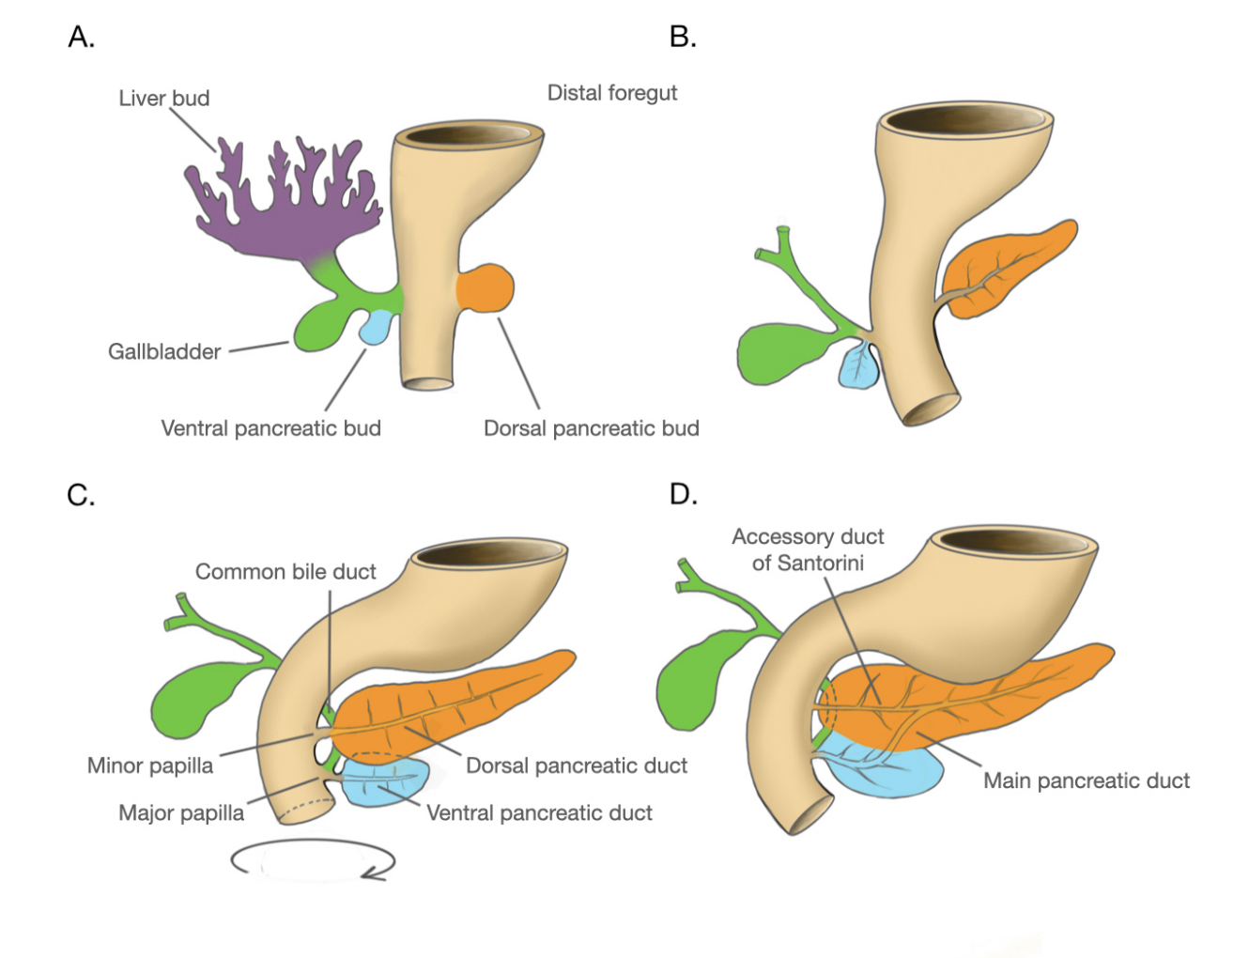

Ductal Anatomy & Anastomosis
After fusion, the principal ducts of the two primordia anastomose — this produces the definitive ductal pattern:
Duct | Derivation
Main pancreatic duct (duct of Wirsung) | Terminal portion = duct of ventral pancreas; distal (most of main duct) = duct of dorsal pancreas
Proximal Wirsung | Joins the CBD on ~day 32, contributing to formation of the ampulla of Vater
Accessory duct (duct of Santorini) | Proximal portion of the dorsal pancreatic duct

Histogenesis — Exocrine & Endocrine
Two populations of endodermal cells develop:
- Those forming ducts and acini (exocrine)
- Those forming islet cells (endocrine)

Ducts and acini form first, but islet primordia bud off the ducts as soon as they are formed — the two lineages are not strictly sequential.
Event | Timing
Secretory acini appear | 3rd month
Islets of Langerhans arise from acini | End of 3rd month
Functional awakening — both endocrine & exocrine | ~10–12 weeks
Insulin secretion begins | ~5th month
Glucagon-secreting α-cells | Present early (glucagon appears at 6 weeks — before insulin)
Somatostatin-secreting δ-cells | Present by 8 weeks

[TIP]Key sequence: Glucagon appears before insulin (6 vs 10 weeks) — reflecting α-cell differentiation preceding β-cell maturation. This is physiologically significant: glucagon promotes glycogenolysis in the fetal liver, supporting early fetal glucose homeostasis before insulin-mediated anabolism is established.

Molecular Basis
Pancreatic specification from foregut endoderm:
- PDX1 (Pancreatic Duodenal Homeobox 1 / IPF1) — the master regulator; expressed throughout the developing pancreas from both primordia; PDX1-null mice have complete pancreatic agenesis; heterozygous PDX1 mutations in humans → MODY4
- PTF1A (Pancreas Transcription Factor 1A) — required together with PDX1 for early pancreatic specification; PTF1A mutations → pancreatic agenesis + cerebellar hypoplasia
- SOX9 — maintains pancreatic progenitor cell identity; co-expressed with PDX1 in early progenitors
- FOXA2 (HNF3β) — pioneer transcription factor; opens chromatin at pancreatic loci to allow PDX1 binding

Clinical Correlations

Annular Pancreas
- Malrotation of the ventral primordium in the 5th week — it fails to rotate normally and encircles the duodenum
- Results in a ring of pancreatic tissue surrounding the 2nd part of the duodenum → duodenal obstruction
- Presents as duodenal obstruction — bilious vomiting, double bubble sign on AXR
- May be asymptomatic until adulthood (incomplete obstruction)
- Treatment: duodenojejunostomy or duodenoduodenostomy — never divide the ring (contains functional pancreatic tissue and ducts)
- Associated with Down syndrome and other duodenal anomalies

Pancreas Divisum
- Most common congenital pancreatic anomaly (~5–10% of population)
- Failure of ductal anastomosis between dorsal and ventral primordia after fusion
- Dorsal duct (duct of Santorini) drains the majority of the pancreas through the minor papilla — a relatively small opening
- Ventral duct (Wirsung) drains only the head/uncinate through the major papilla
- Most asymptomatic; minority develop recurrent acute pancreatitis or chronic pancreatitis due to relative outflow obstruction through the minor papilla
- Treatment (symptomatic): minor papilla sphincterotomy or surgical drainage

Ectopic Pancreatic Tissue
- Misdirected differentiation of multipotent foregut endodermal progenitors
- Most common sites: stomach (antrum/pylorus), duodenum, jejunum, Meckel's diverticulum
- Usually asymptomatic; can cause obstruction, bleeding, or mimic malignancy on imaging
- Requires PDX1 expression outside normal pancreatic primordium — reflects retained multipotency

Insulinoma / Glucagonoma — embryological context
- Arise from islet cells that, in development, bud off from ductal epithelium
- The shared ductal-endocrine progenitor explains why some pancreatic tumours have mixed exocrine-endocrine features (e.g., pancreatoblastoma — a tumour of early pancreatic progenitors)
- Pancreatoblastoma — recapitulates embryonic pancreas; most common malignant pancreatic tumour in children; associated with Beckwith-Wiedemann syndrome

Key Points to Remember
- Ventral primordium → head (part) + uncinate process + proximal Wirsung; joins CBD to form ampulla of Vater
- Dorsal primordium → body, tail, remainder of head and uncinate + accessory duct (Santorini) + most of main duct
- Glucagon appears before insulin (6 vs 10 weeks) — α-cells mature before β-cells
- PDX1 = master pancreatic regulator; null → agenesis; heterozygous → MODY4
- NGN3 = pro-endocrine switch — high Notch suppresses it; low Notch allows endocrine fate
- Pancreas divisum = failed ductal anastomosis (not failed fusion of primordia)
- Annular pancreas = malrotation of ventral primordium — never divide the ring surgically
- Islets bud from ducts as soon as ducts form — the two lineages overlap, not strictly sequential
- Endocrine cells are of endodermal (not neural crest) origin — Debas hypothesis now supported

